**Open Source Graphics & Animation Tools**



**Chandrayaan 2**

**Mid-Semester Phase 1**

**Submitted to**

**Dr. Durgansh Sharma**

**Professor, Cybernetics SCS, UPES**

**Submitted By**

Name: Avijeet Kumar

Roll No: 10

SAP ID: 500067577

B. Tech CSE (OSSOS) Department of Cybernetics

COMPUTER SCIENCE & ENGINEERING

**ABSTRACT INFORMATION:**

Demonstrating Chandrayaan 2 through GIMP.

**PROCEDURE:**

**Layer 1 -**

1. **Take a sheet of GIMP with 400*400 px with a background color black.**

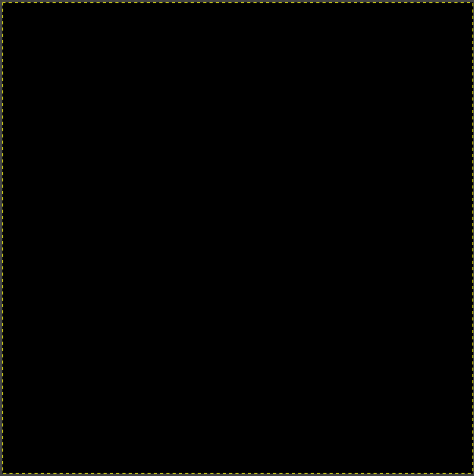

**Layer 2 –**

1. **Select noise from the RGB color filter and use the saturation and opacity to form a colourful texture.**

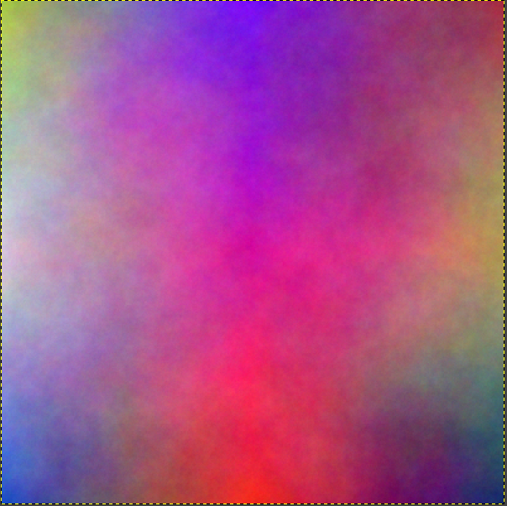

**Layer 3 -**

1. **Now lower the saturation of the filter to apply darkness theme to it.**
2. **Make the opacity upto 50.**

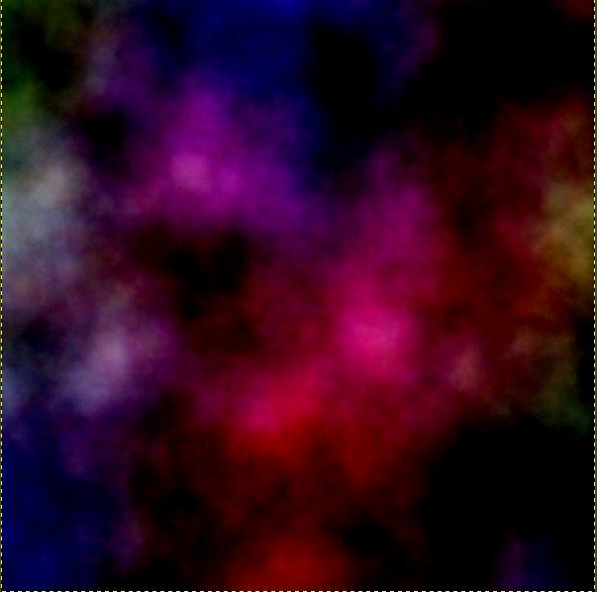

**Layer 4 –**

1. **Decrease the saturation a little further and add HSV noise filter to it.**
2. **Now we have got a cloud and space like appearance.**

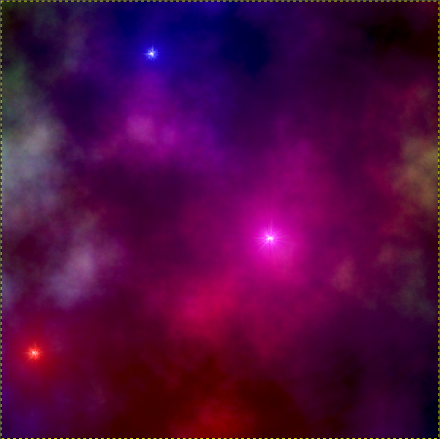

**Layer 5 -**

1. **From the Filter options select sparkles, this will add stars to the space we created.**

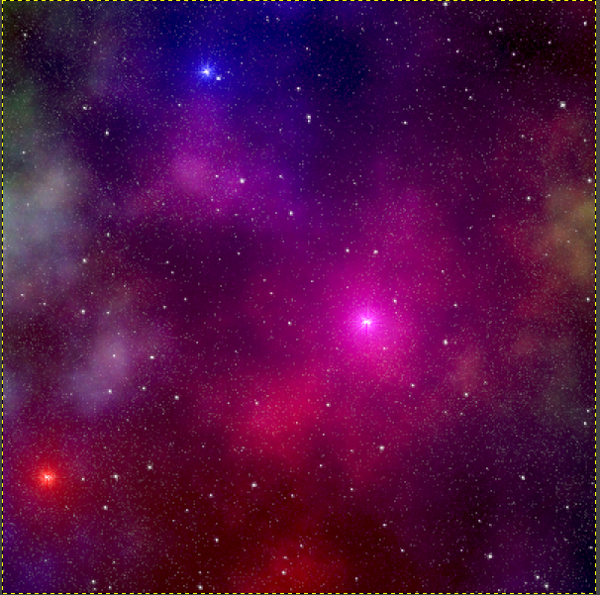

**Layer 6 –**

1. **Again, add the sparkles from the filter option.**
2. **This will add to the brightness and number of stars already available.**

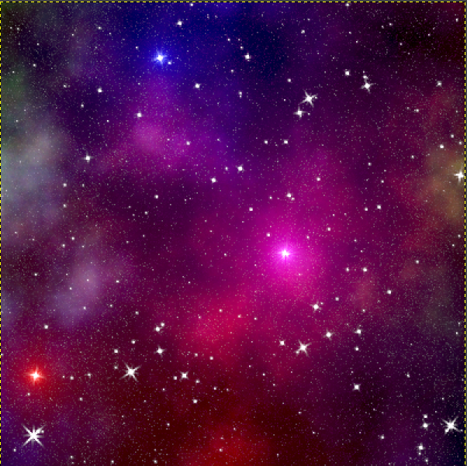

**Layer 7 –**

1. **Add the noise filter and select HSV color from noise from there.**
2. **This will add much brightness to the color.**

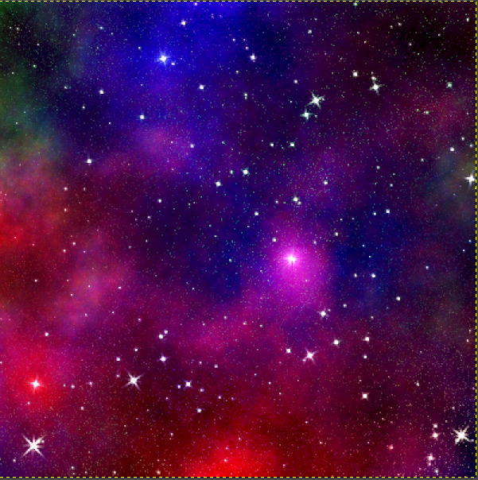

**Layer 8 -**

1. **Apply the cropped piece(traced) of rocket to the already made layer by adding a new layer and pasting it on the top.**
2. **Remember to add the earth and then the space shuttle onto it as show that the shuttle is going from earth.**

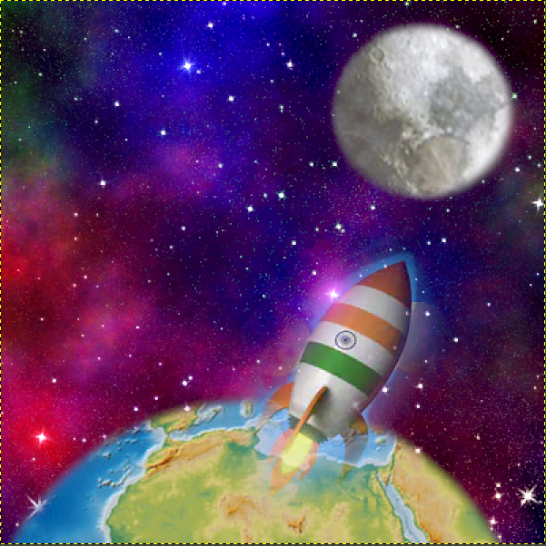

Number of Layers Used:9(Including text layers)

Font used in text: JOKERMAN

Kerning in text: 0.0

Leading in text: 0.1

Tracking in text: 0.2

Text Size: 36-38

Text Colour: Orange, White, Green, Yellow

Text Opacity: 100%

**FINAL OUTCOME:**

